Colin Fausnaught

Challenges

1. //Ch2Cha1  
  
public class Ch2Cha1  
{  
 public static void main(String[] args)  
 {  
 //variables   
 String name;  
 int age;  
 double annualPay;  
   
 //storing  
 name = "Colin Fausnaught";  
 age = 17;  
 annualPay = 100000.00;  
   
 //printing  
 System.out.println("My name is " + name + ", my age is "  
 + age + " and\nI hope to earn $" + annualPay + " per year.");  
   
   
 }  
}

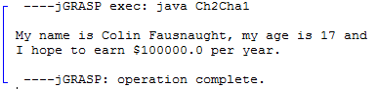

2. //Ch2Cha2.java  
  
public class Ch2Cha2  
{  
 public static void main(String[] args)  
 {  
 //variables  
 String firstName, middleName, lastName;  
 char firstInitial, middleInitial, lastInitial;  
   
 //storing  
 firstName = "Colin";  
 middleName = "Joseph";  
 lastName = "Fausnaught";  
 firstInitial = firstName.charAt(0);  
 middleInitial = middleName.charAt(0);  
 lastInitial = lastName.charAt(0);  
   
 //printing  
 System.out.println("First name: " + firstName + "\nMiddle name: "  
 + middleName + "\nLast name: " + lastName + "\nFirst initial: "  
 + firstInitial + "\nMiddle initial: " + middleInitial + "\nLast initial: "  
 + lastInitial );  
   
 }  
 }

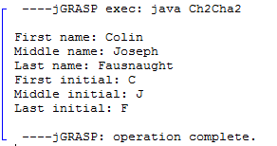

3. //Ch2Cha3  
  
public class Ch2Cha3  
{  
 public static void main(String[] args)  
 {  
 //variables  
 String name, address, number, major;  
   
 //storing  
 name = "Colin J. Fausnaught\n";  
 address = "1885 Ravine Rd Williamsport PA, 17701\n";  
 number = "570-326-5181\n";  
 major = "Computer Enginering\n";  
   
 //print  
 System.out.println(name + address + number + major);  
 }  
}

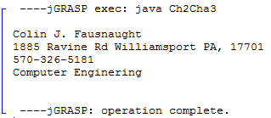

4. //Ch2Cha4.java  
  
public class Ch2Cha4  
{  
 public static void main(String[] args)  
 {  
 //print  
 System.out.print(" \* \n");  
 System.out.print(" \*\*\* \n");  
 System.out.print(" \*\*\*\*\* \n");  
 System.out.print("\*\*\*\*\*\*\*\n");  
 System.out.print(" \*\*\*\*\* \n");  
 System.out.print(" \*\*\* \n");  
 System.out.println(" \* \n");  
 }  
}

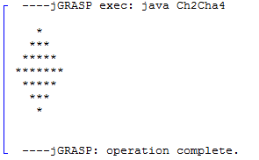

5. //Ch2Cha5.java  
  
public class Ch2Cha5  
{  
 public static void main(String args[])  
 {  
 //variables  
 int num1, num2, total;  
   
 //assign  
 num1 = 62;  
 num2 = 99;  
   
 total = num1 + num2;  
   
 //print  
 System.out.println("Sum is: " + total );  
 }  
}

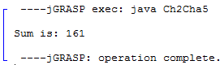

6. //Ch2Cha6.java  
  
public class Ch2Cha6  
{  
 public static void main(String args[])  
 {  
 //variables  
 final double SALES = 4600000;  
 final double PERCENT = 0.62;  
 double east;  
   
 //assign  
 east = SALES \* PERCENT;  
   
 //print  
 System.out.println("East Coast sales division total: $" + east);  
   
 }  
   
}

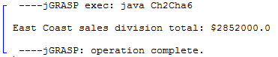

7. //Ch2Cha7.java  
  
public class Ch2Cha7  
{  
 public static void main(String args[])  
 {  
 //variables  
 final double TRACT = 389767;  
 final double ACRE = 43560;  
 double acres = 0.0;  
   
 //assign  
 acres = TRACT / ACRE;  
   
 //print  
 System.out.println("There are " + acres + " acres.");  
 }  
}

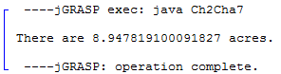

12. //Ch2Cha12.java  
  
import java.util.Scanner;  
  
public class Ch2Cha12  
{  
 public static void main(String args[])  
 {  
 //variables  
 String city, cUp, cLow;  
 char cChar;  
 int number;  
   
 //scanner  
 Scanner keyboard = new Scanner(System.in);  
   
 //inputs  
 System.out.print("Enter favorite city: ");  
 city = keyboard.nextLine();  
   
 //convert and store into variables  
 number = city.length();  
 cUp = city.toUpperCase();  
 cLow = city.toLowerCase();  
 cChar = city.charAt(0);  
   
 //display  
 System.out.print("\nNumber of Characters: " + number);  
 System.out.print("\nUppercase: " + cUp);  
 System.out.print("\nLowercase: " + cLow);  
 System.out.print("\nName of city: " + city);  
 System.out.println("\nFirst letter: " + cChar);  
   
 }  
}

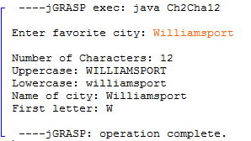

13. //Ch2Cha13.java  
import java.util.Scanner;  
  
public class Ch2Cha13  
{  
 public static void main(String[] args)  
 {  
 //variables  
 double meal, fTax, fTip, total;  
 final double TAX = 0.0675;  
 final double TIP = 0.15;  
   
 //scanner  
 Scanner keyboard = new Scanner(System.in);  
   
 //input  
 System.out.print("Enter the price of your meal: ");  
 meal = keyboard.nextDouble();  
   
 //calculate  
 fTax = meal \* TAX;  
 fTip = (fTax + meal) \* TIP;  
 total = fTip + fTax + meal;  
   
 //output  
 System.out.print("\nMeal Charge: " + meal);  
 System.out.print("\nTax: " + fTax);  
 System.out.print("\nTip: " + fTip);  
 System.out.print("\nTotal: " + total);  
 }  
   
}

